**AMI user setup:**

Go to FreePBX portal, press “Settings” and select “Asterisk Manager Users”.

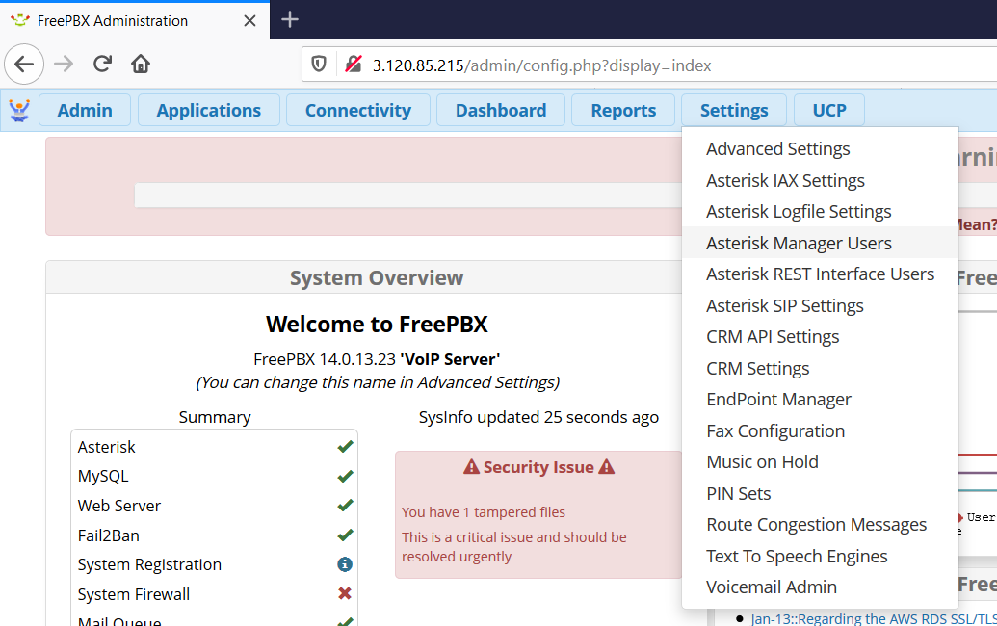

Press “Add Manager”

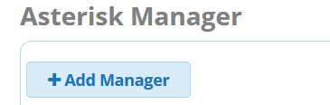

Add username and set password as following. Here in Permit field add IP of machine where vQube connector is running.

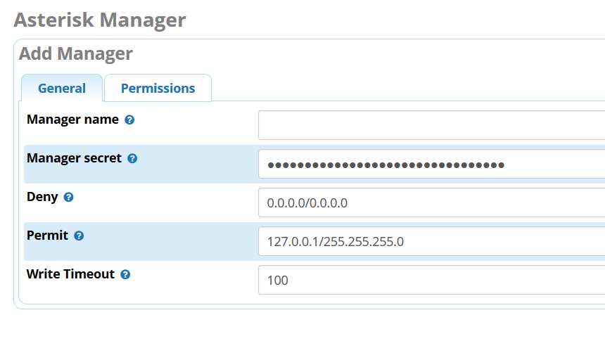

Save the settings. Now you can use this user for vQube AMI settings: <https://github.com/virtualq/vQube-Release/wiki/2.-vQube-Dashborad-Configuration#ami-configuration>